**Project Name : PJ Margo**

**Error : Unable to connect to display unit.**

**Handled By : Muthiah. G K**

The error occurred during the transfer of the program to IPC.

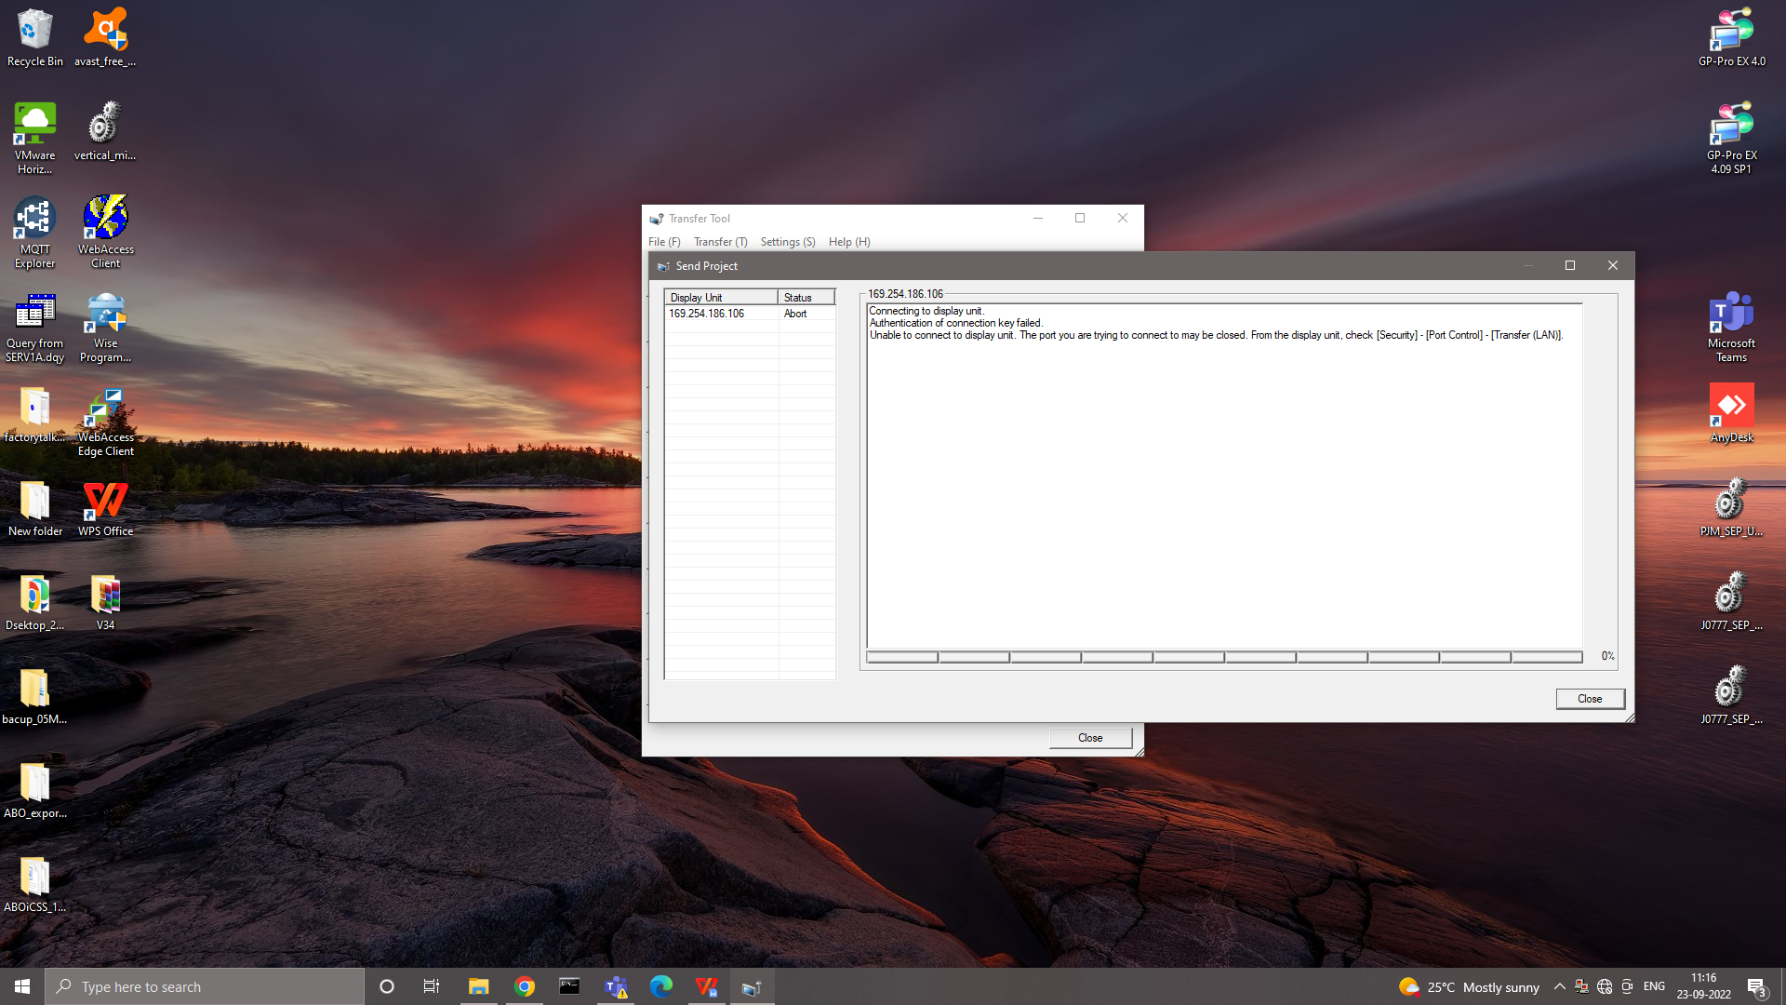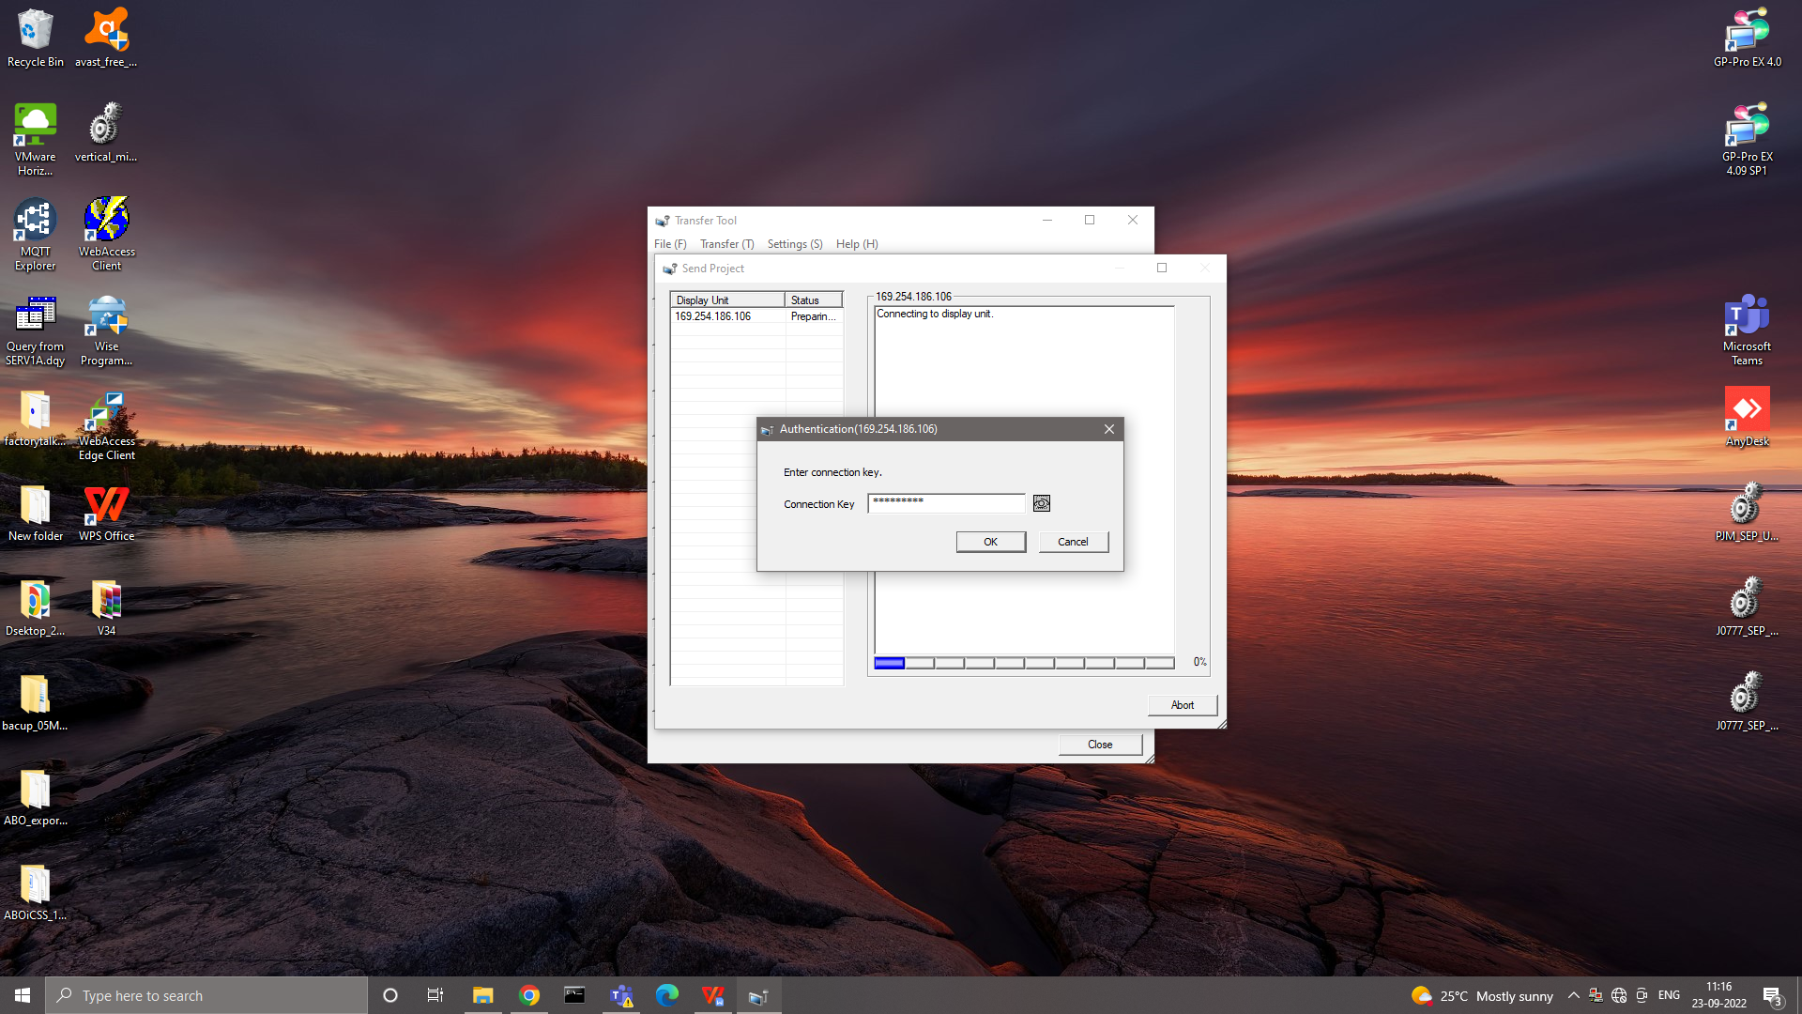

We initially transfer the program by giving the connection key.

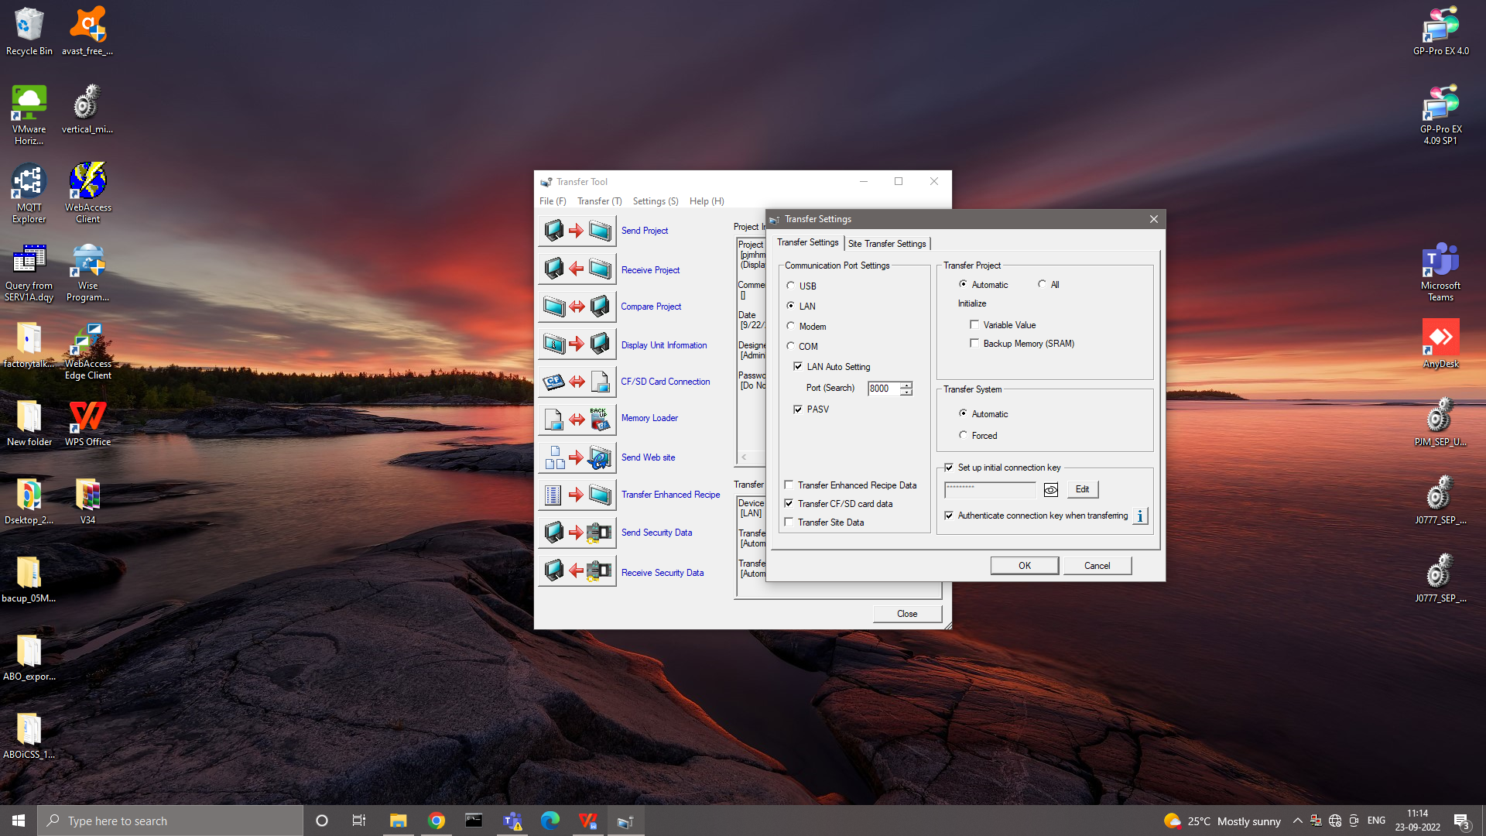

The transfer was not successful.



We tried changing the port, Ethernet cables. However, it was not resolved. Then we checked the port control.

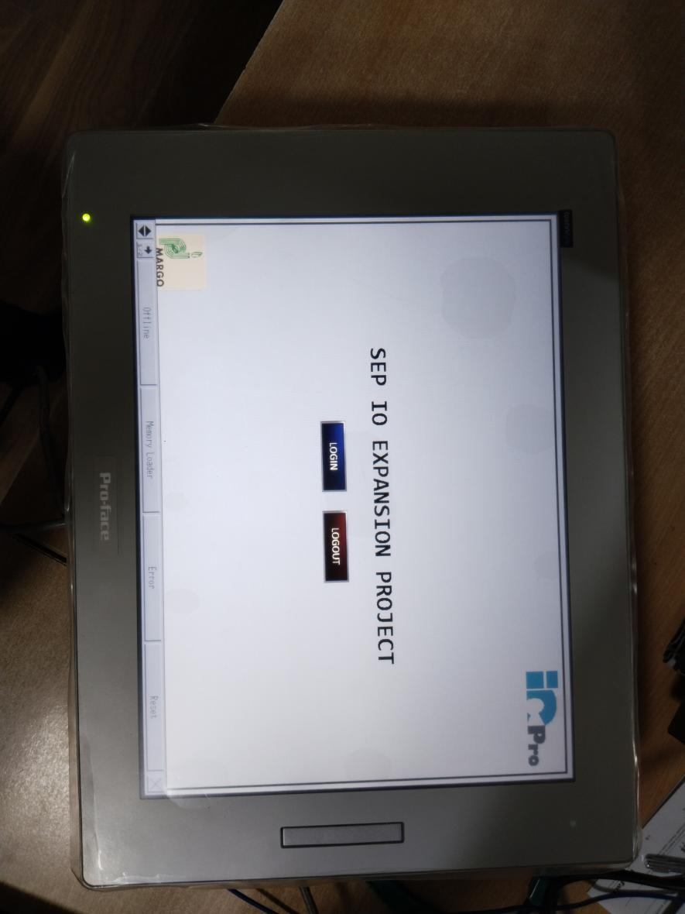

To go to port control open  **Offline -> Security Settings -> Port Control**

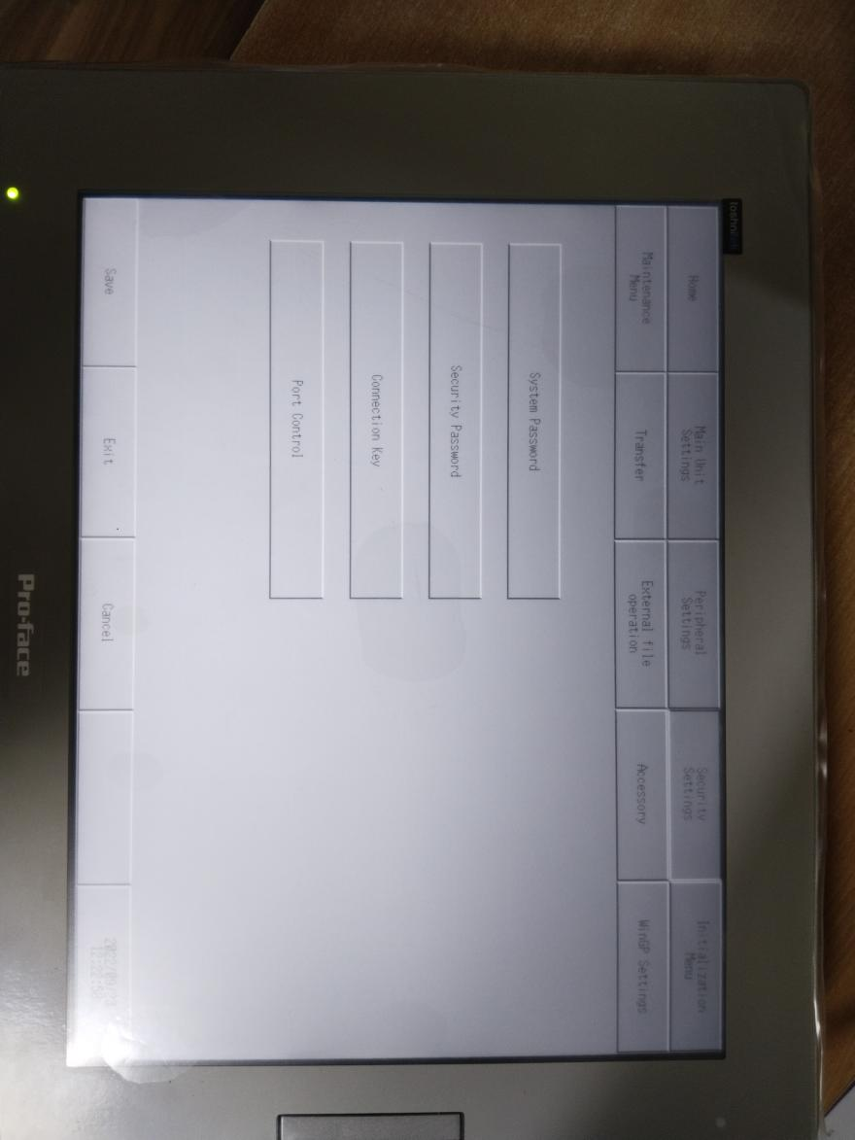

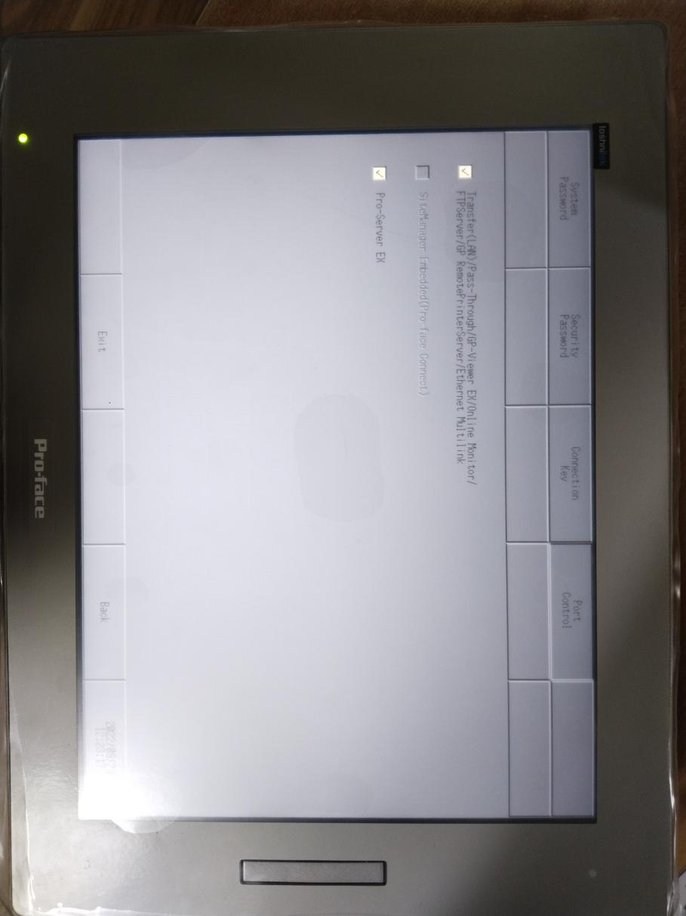

In that everything was right and then we found that the error occurred because of the connection key.

To go to connection key open  **Offline -> Security Settings -> Connection key**

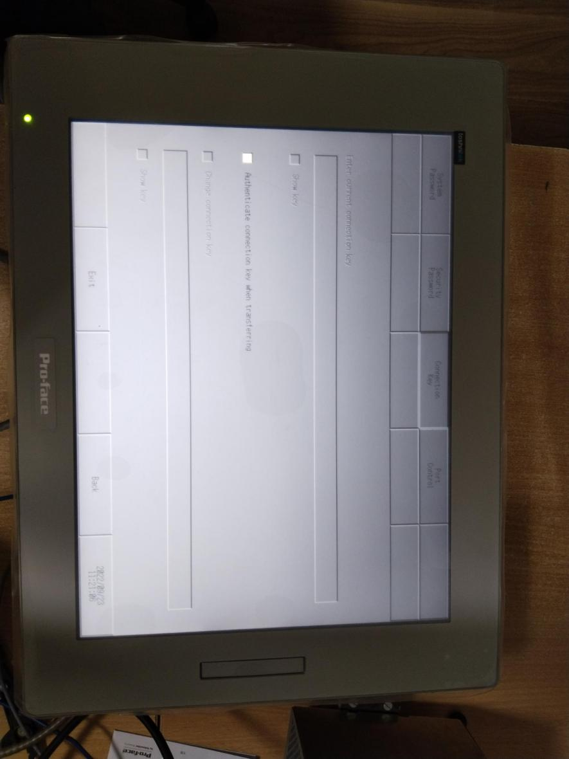

We disabled the connection key in the IPC (HMI) & in transfer settings.

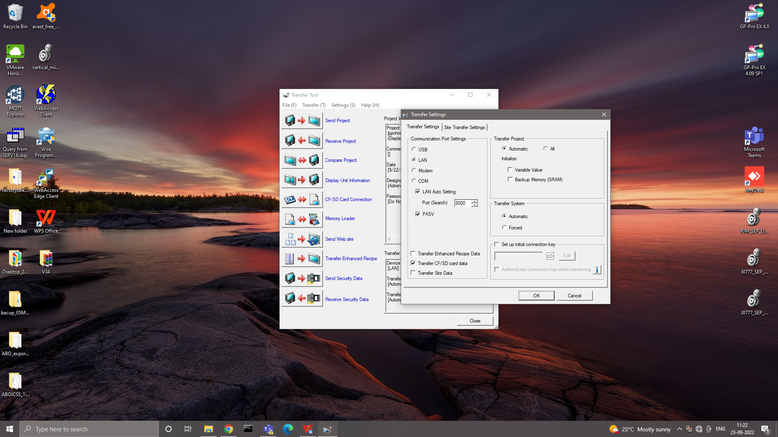

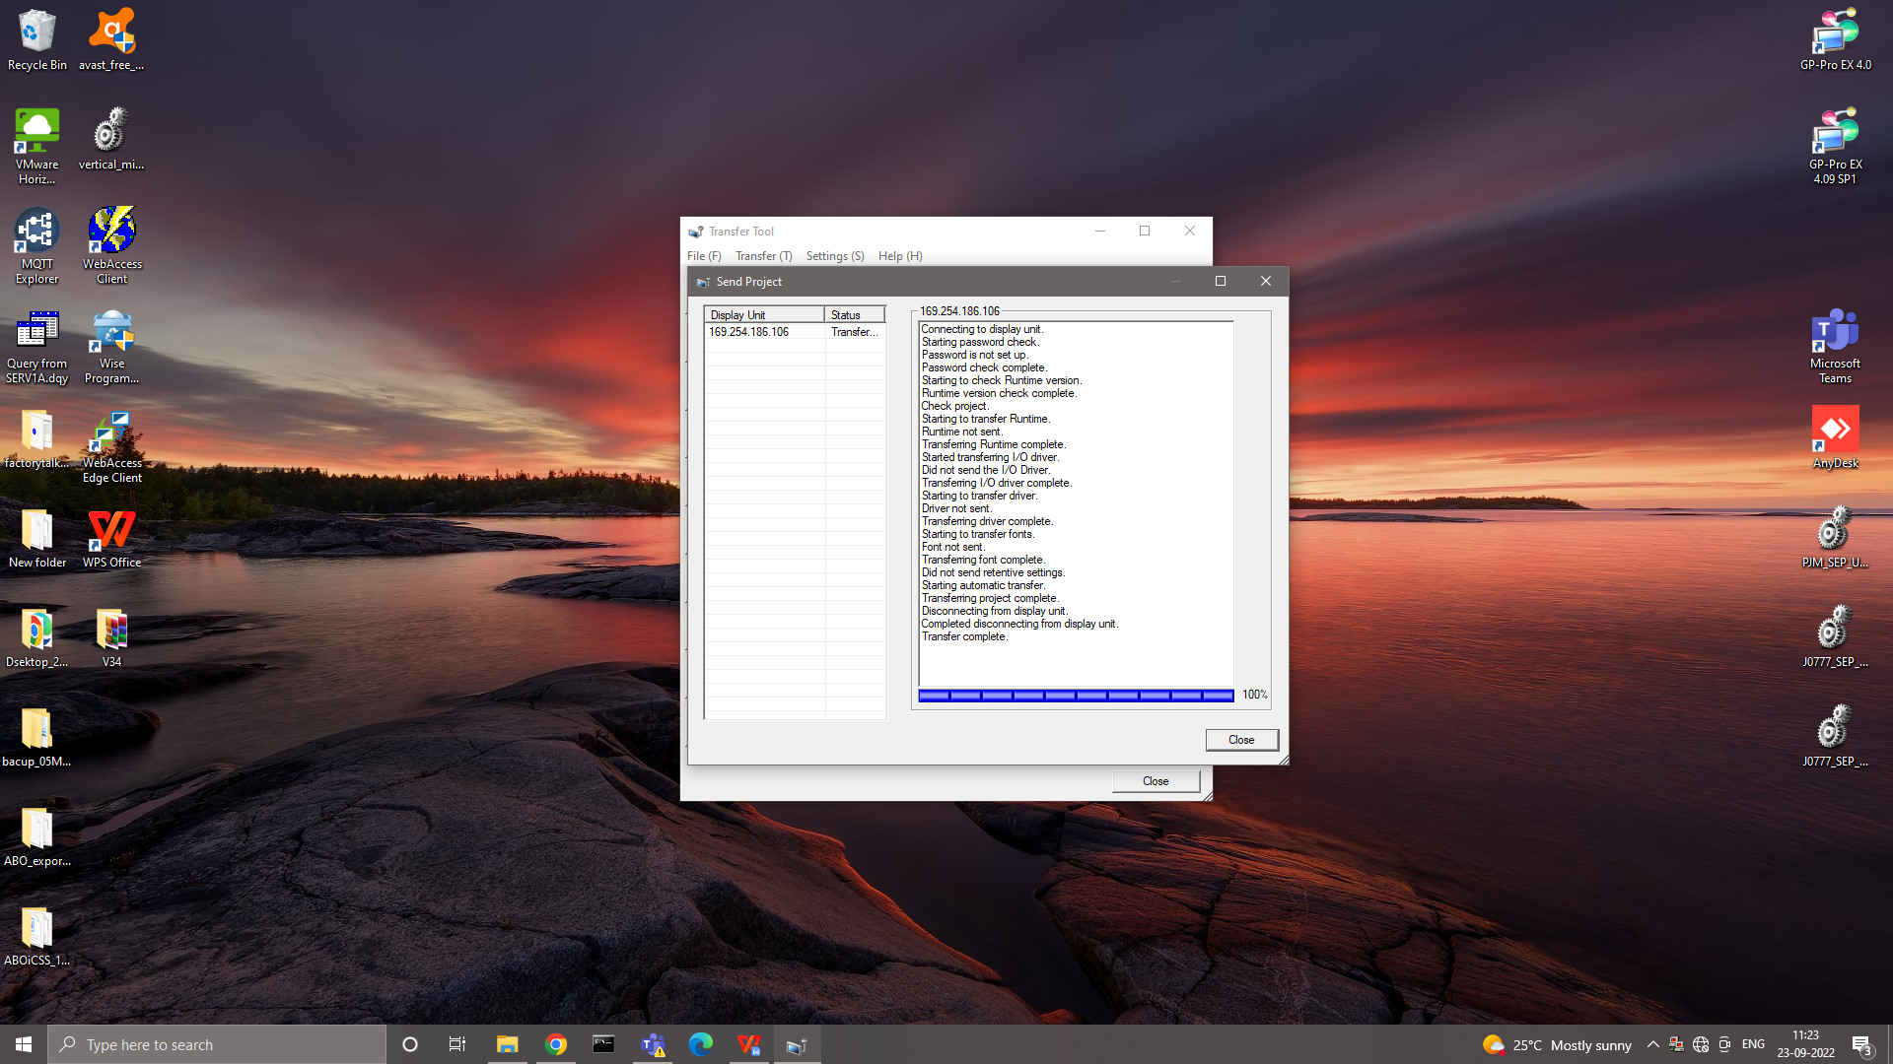

Then we tried to the transfer the program and it was successful.

